AI-AcadPredict
AI-Integrated Academic Project Management and Delay Risk Prediction Platform

BACHELOR OF TECHNOLOGY
In
DEPARTMENT OF COMPUTER SCIENCE AND ENGINEERING

Or
DEPARTMENT OF COMPUTER SCIENCE AND INFORMATION TECHNOLOGY

Or
DEPARTMENT OF ARTIFICIAL INTELLIGENCE AND DATA
SCIENCE
By
R.L.S. Giridhar-2420030171
B. Srihitha - 2420030099
V. Sai Dhanush - 2420030162
V. Mani MahaLakshmi - 2420030773

Under the Esteemed Guidance of

Dr. G. Lavanya

Name of the Applied Machine Learning for Text Analytics Faculty




K L (Deemed to be) University
DEPARTMENT OF COMPUTER SCIENCE AND ENGINEERING
Or
DEPARTMENT OF COMPUTER SCIENCE AND INFORMATION TECHNOLOGY

Or
DEPARTMENT OF ARTIFICIAL INTELLIGENCE AND DATA
SCIENCE

DECLARATION

The mini-project report entitled “AI-AcadPredict” is a record of bona fide work carried out by [Names and Roll Numbers] in partial fulfillment of the requirements for the award of the B.Tech degree at K L (Deemed to be) University. The work presented in this report is original to the best of our knowledge, and all datasets, tools, code, and external sources used have been appropriately acknowledged.
R.L.S. Giridhar-2420030171
B. Srihitha - 2420030099
V. Sai Dhanush - 2420030162
V. Mani MahaLakshmi - 2420030773

K L (Deemed to be) University
DEPARTMENT OF COMPUTER SCIENCE AND ENGINEERING
Or
DEPARTMENT OF COMPUTER SCIENCE AND INFORMATION TECHNOLOGY

Or
DEPARTMENT OF ARTIFICIAL INTELLIGENCE AND DATA
SCIENCE
CERTIFICATE

This is to certify that the mini-project report entitled “AI-AcadPredict” is a bona fide work carried out by [Student Names and Roll Numbers] under the supervision of Dr. G. Lavanya during the academic year [2026–2027], in partial fulfillment of the requirements for the award of the Bachelor of Technology degree at K L (Deemed to be) University.

Signature of the Project Supervisor
Dr. G. Lavanya

Signature of the HOD Signature of the External Examiner

ACKNOWLEDGEMENT

The success in this project would not have been possible but for the timely help and guidance rendered by many people. Our wish to express my sincere thanks to all those who has assisted us in one way or the other for the completion of my project.

Our greatest appreciation to my guide, Dr. G. Lavanya, Department of Computer Science which cannot be expressed in words for his/her tremendous support, encouragement and guidance for this project.

We express our gratitude to Dr. P.Venkateshwar Sir (CSE)/Dr. Kaja Shareef Sir (CSIT)/Dr.Sreenath, Head of the Department for Computer Science Engineering/ Department for Computer Science and Information Technology/ Department Of Artificial Intelligence And Data Science for providing us with adequate facilities, ways and means by which we are able to complete this project-based Lab.

We thank all the members of teaching and non-teaching staff members, and also who have assisted me directly or indirectly for successful completion of this project. Finally, I sincerely thank my parents, friends and classmates for their kind help and cooperation during my work.

R.L.S. Giridhar-2420030171
B. Srihitha - 2420030099
V. Sai Dhanush - 2420030162
V. Mani MahaLakshmi - 2420030773

TABLE OF CONTENTS

S.No. | Contents | Page no.
1 . | Abstract | 6
2. | Introduction | 7
3. | Literature survey | 8
4. | Problem Statement and Objectives | 13
5. | Hardware and Software requirements | 14
6. | Implementation | 15
7. | Results & Discussion | 17
8. | Conclusion & Future Scope | 20
9. | References | 21

1. ABSTRACT
Project Title: AI-AcadPredict: AI-Integrated Academic Project Collaboration and Delay Risk Prediction Platform
Abstract
Academic project teams often face challenges in monitoring task completion, tracking milestones, and identifying potential delays. AI-AcadPredict proposes an AI-integrated academic project collaboration platform that combines machine learning with adaptive workflow automation to support early identification of project delay risks. The system uses project-related features, including task completion percentage, pending tasks, missed deadlines, and milestone completion, to classify projects into low, medium, or high delay-risk categories. The proposed technology stack includes React.js for the frontend, Spring Boot and Java for backend services, MySQL for data storage, and Python, Scikit-learn, and FastAPI for machine-learning integration. A Random Forest classifier is planned for risk prediction, with model performance evaluated using accuracy, precision, recall, F1-score, and a confusion matrix. Predicted risk levels will support predefined workflow actions, including reminders and alerts for faculty and coordinators. The project aims to improve academic project monitoring and enable timely intervention
Team Members and Responsibilities
- V. Mani MahaLakshmi, Roll No. – Frontend development using React.js.
- V. Sai Dhanush, Roll No. 2420030162 – Backend development using Spring Boot and authentication.
- B. Srihitha, Roll No. 2420030099 2420030162 – Machine-learning model development and FastAPI integration.
- R.L.S. Giridhar, Roll No. 2420030171– Database design, testing, and documentation.
Supervisor: Dr. G. Lavanya
Dataset/Source and Project Repository
- Dataset: To be finalized and validated for project delay-risk prediction.
- Dataset Source: A suitable public dataset will be selected after verifying that its features and target variable support the prediction task.
- Project Repository: Add the team's GitHub repository URL when available.
- Current Phase: Requirements analysis and Jira product backlog preparat

2. INTRODUCTION

Academic project management is an important part of higher education, where students collaborate in teams to complete projects under the guidance of faculty members. However, monitoring project progress, tracking milestones, identifying incomplete tasks, and detecting potential delays can be challenging when multiple teams and projects are managed simultaneously. AI-AcadPredict: AI-Integrated Academic Project Collaboration and Delay Risk Prediction Platform proposes a centralized platform that combines project collaboration, machine learning, and adaptive workflow automation to support effective academic project monitoring.
The application focuses on predicting the risk of academic project delays using structured project-related data. Manually reviewing progress reports and monitoring every team's activities requires considerable time and effort, making it difficult to identify potential problems early. Machine learning can analyse patterns in historical or collected project data to identify factors associated with delays and classify projects into low, medium, or high delay-risk categories. This helps faculty guides and project coordinators identify projects that may require additional attention and take timely action.
The primary target users are students, faculty guides, and project coordinators. Students can manage project tasks, update milestones, and monitor progress. Faculty guides can review submissions, provide feedback, and track team performance, while coordinators can monitor projects across teams and receive risk alerts. The input to the prediction system consists of structured features such as task completion percentage, pending tasks, missed deadlines, and milestone completion percentage. The predicted output is the project's delay-risk category.
The proposed pipeline includes data collection, data cleaning and preprocessing, feature selection, model training using a Random Forest classifier, and evaluation using accuracy, precision, recall, F1-score, and a confusion matrix. The trained model will be integrated into the platform through a Python FastAPI service, with React.js providing the user interface, Spring Boot managing backend operations, and MySQL storing application data. Based on predicted risk levels, predefined rules can trigger reminders and alerts to support timely intervention.

3. LITERATURE SURVEY
AI-AcadPredict currently predicts academic project delay risk from structured data such as pending tasks, missed deadlines, and milestone completion. Your assignment specifically asks for text analytics. To align both, you could extend the project to analyse the free-text content of student progress reports and classify them into categories such as on track, at risk, or delayed. The following literature survey reviews established text-classification research that can inform this approach. These papers provide methodological foundations, but they do not directly validate a model for academic project delay prediction.
3.1 Review of Existing Research
1. Sebastiani (2002) — Machine Learning in Automated Text Categorization
- Problem: The paper surveys how documents can be automatically assigned to predefined categories instead of being classified manually.
- Data and method: It reviews text-categorization research using labelled document collections, document representations, and supervised machine-learning classifiers.
- Evaluation: It discusses classifier evaluation methods and the importance of selecting suitable representations and performance measures.
- Main finding: Machine learning can reduce manual categorisation effort and make document classification adaptable to different subject areas.
- Limitation and relevance: This is a broad survey rather than a project-delay experiment. Its principles can guide the conversion of student progress reports into machine-readable features and risk-related categories
2. Pang, Lee, and Vaithyanathan (2002) — Thumbs Up? Sentiment Classification Using Machine Learning Techniques
- Problem: The study investigates how to classify the overall sentiment of movie reviews as positive or negative.
- Dataset and method: It uses movie-review text and compares Naive Bayes, maximum entropy, and Support Vector Machine (SVM) classifiers.
- Evaluation: The authors compare model performance with human-produced baselines and examine the difficulty of sentiment classification.
- Main finding: Standard machine-learning methods outperform the human-produced baselines considered in the study, although sentiment classification remains more challenging than conventional topic categorisation.
- Limitation and relevance: Movie reviews differ from academic progress reports, and sentiment is not equivalent to project delay risk. Nevertheless, the study demonstrates how labelled text can be used for supervised classification
3. Maas et al. (2011) — Learning Word Vectors for Sentiment Analysis
- Problem: This research explores how word representations can capture useful information for sentiment classification.
- Dataset and method: The authors introduce a large movie-review dataset containing 50,000 labelled reviews, split into 25,000 training and 25,000 testing examples, alongside additional unlabelled reviews. The work investigates word-vector representations for sentiment analysis.
- Evaluation: The paper evaluates sentiment-classification performance; the original dataset page reports 88.89% test accuracy for the original 2011 work.
- Main finding: Representations that capture semantic information can support effective classification of written reviews.
- Limitation and relevance: The data concerns movie reviews rather than student reports, so its vocabulary and labels do not transfer directly to academic project risk. Its dataset and representation approach provide a useful benchmark for understanding text-based learning
4. Minaee et al. (2020) — Deep Learning Based Text Classification: A Comprehensive Review
- Problem: The authors review deep-learning approaches for classifying text across tasks such as sentiment analysis, news categorisation, and question answering.
- Data and method: The review covers more than 150 deep-learning models and over 40 datasets, including neural networks, CNNs, RNNs, attention-based models, and Transformers.
- Evaluation: The authors quantitatively analyse selected models on 16 established benchmarks rather than conducting one new experiment on a single dataset.
- Main finding: Neural text representations can capture contextual and semantic information that traditional hand-crafted features may miss.
- Limitation and relevance: Deep-learning approaches can require more computing resources and data, and their results on established benchmarks may not transfer directly to academic progress reports. This supports comparing a simpler TF-IDF baseline with more advanced representations if resources permit
5. Palanivinayagam, El-Bayeh, and Damaševičius (2023) — Twenty Years of Machine-Learning-Based Text Classification: A Systematic Review
- Problem: The study examines how machine learning has been applied to text-classification tasks and how research methods and evaluation practices differ.
- Data and method: The authors systematically review 224 papers published between 2003 and 2022, following PRISMA-guided selection and analysis.
- Evaluation: They compare the literature by dataset, algorithm, reported accuracy, evaluation metrics, train-test splitting, and model comparisons.
- Main finding: SVM, Naive Bayes, and k-nearest neighbours are widely used classifiers, while accuracy is a common metric; the review also identifies areas needing improvement.
- Limitation and relevance: Because the study aggregates many tasks and datasets, it does not identify one classifier that will necessarily work best for academic project reports. It highlights the need to test models on the target dataset rather than assume performance from other domains.
3.2 Comparison of Existing Approaches
Approach | Strength | Limitation for AI-AcadPredict
Traditional supervised learning, such as Naive Bayes and SVM | Practical baseline for labelled text; relatively straightforward to train | May not fully capture context and domain-specific meaning
Word-vector representations | Represent semantic relationships between words | Performance depends on representation quality and similarity between training and target domains
Deep learning and Transformers | Can capture richer contextual information | May require more data, computing resources, and careful evaluation
General text-classification surveys | Help identify common methods, datasets, and evaluation practices | Do not provide a ready-made model or labels for academic project delay risk
These studies demonstrate that text classification can reduce manual document-review effort, but model performance depends on the data, labels, text representation, and evaluation design. A model trained on movie reviews or news articles cannot simply be assumed to predict academic project delays accurately.

3.3 Research Gap
The reviewed studies primarily address general text categorisation, sentiment analysis, or benchmark classification tasks. They do not directly establish a method for identifying delay risk from academic project progress reports and connecting that prediction to an academic collaboration workflow.
AI-AcadPredict can address this gap by investigating a domain-specific text-classification pipeline that:
- Collects student-written project progress updates and associates them with verified project outcomes.
- Cleans and preprocesses text, including handling punctuation, inconsistent spelling, and irrelevant content.
- Converts the text into numerical features using TF-IDF as an initial baseline.
- Trains and compares suitable classifiers using labelled progress reports.
- Evaluates performance using precision, recall, F1-score, and a confusion matrix, with particular attention to correctly identifying delayed projects.
- Connects predicted risk categories to the platform's existing reminder and escalation rules.
The proposed contribution is the combination of text-based risk analysis with project collaboration and adaptive workflow actions. This remains a proposed research direction: its effectiveness must be demonstrated using a suitable dataset with reliable labels. If the team retains only structured project features and does not analyse text, the project should instead be described as structured-data risk prediction, and the literature survey should be adjusted accordingly.

4. PROBLEM STATEMENT AND OBJECTIVES

4.1 Problem Statement
Academic project teams often face difficulties in tracking progress and identifying delays. Manually reviewing student progress reports takes time and may delay the identification of problems. Therefore, AI-AcadPredict aims to analyse student progress reports using NLP and machine learning to classify projects into Low Risk, Medium Risk, and High Risk categories.

4.2 Problem Description
Students submit progress reports describing completed tasks, pending work, and technical problems. Reviewing many reports manually can be difficult for faculty guides and project coordinators. The proposed system analyses report text using TF-IDF and machine learning models to identify potential project delays and support timely action.

4.3 Objectives
- To develop a system that classifies academic project progress reports into low, medium, and high delay-risk categories.
- To collect and analyse a suitable labelled text dataset.
- To clean and preprocess the text data.
- To convert text into numerical features using TF-IDF.
- To train and compare Multinomial Naive Bayes and Logistic Regression models.
- To evaluate the models using accuracy, precision, recall, F1-score, and a confusion matrix.
- To identify model errors and limitations.
- To develop a simple interface or API for displaying predictions, if possible.
- To help faculty guides identify projects that may require additional attention.
- To consider data privacy and prediction reliability.

5. HARDWARE AND SOFTWARE REQUIREMENTS
Hardware Requirements
- Computer or laptop with a modern multi-core processor (Intel Core i5 or equivalent and above).
- Minimum 8 GB RAM, with 16 GB recommended for smooth development and model training.
- Minimum 10–20 GB of free disk space for datasets, libraries, trained models, and project files.
- Stable internet connection for downloading datasets and required packages.
- GPU is optional; it may improve performance when using larger machine-learning models.
Software Requirements
- Python 3.x for machine learning and text processing.
- Visual Studio Code or Jupyter Notebook for development.
- Pandas and NumPy for data handling and numerical operations.
- Scikit-learn for text classification, TF-IDF feature extraction, and model evaluation.
- Multinomial Naive Bayes and Logistic Regression for training and comparing classification models.
- NLTK or spaCy for text preprocessing, if required.
- Matplotlib and Seaborn for visualising evaluation results.
- Joblib for saving and loading trained machine-learning models.
- Streamlit or FastAPI for the prediction interface or API, if implemented.
- A labelled text dataset containing academic project progress reports or suitable text examples with delay-risk categories.
- Git and GitHub for version control and source-code management

6. IMPLEMENTATION
- Data and task: describe the text classification/analysis task, target labels, dataset source, licence/usage conditions, number of records, and train/validation/test split.
- NLP preprocessing and features: document missing-value handling, duplicate removal, lowercasing,tokenization, stop-word handling, stemming/lemmatization, and TF-IDF/BoW/embedding choices. Explain any task-specific decisions.
- Model training and evaluation: identify algorithms, hyperparameters, random seed, validation strategy, evaluation metrics, and how the best model was selected. Avoid data leakage by fitting preprocessing only on training data.
- Project workflow and modules
  - • Data loading and exploratory analysis: [filename.py / notebook]
  - • Text cleaning and preprocessing: [filename.py / notebook]
  - • Feature extraction and model training: [filename.py / notebook]
  - • Evaluation, plots, and error analysis: [filename.py / notebook]
- Machine-learning implementation
  - Describe the selected baseline and comparison model(s), such as Multinomial Naive Bayes, Logistic Regression, Linear SVM, Decision Tree, or Random Forest, as suitable for the task.
  - Include key code excerpts or refer to the appendix/repository; explain the purpose of each module and important parameters.
  - C. Demonstration / API (if implemented)
  - Describe the optional Streamlit/Flask/FastAPI interface, input validation, model loading, prediction display, and relevant source files. If no interface is built, document the notebook/CLI workflow instead.
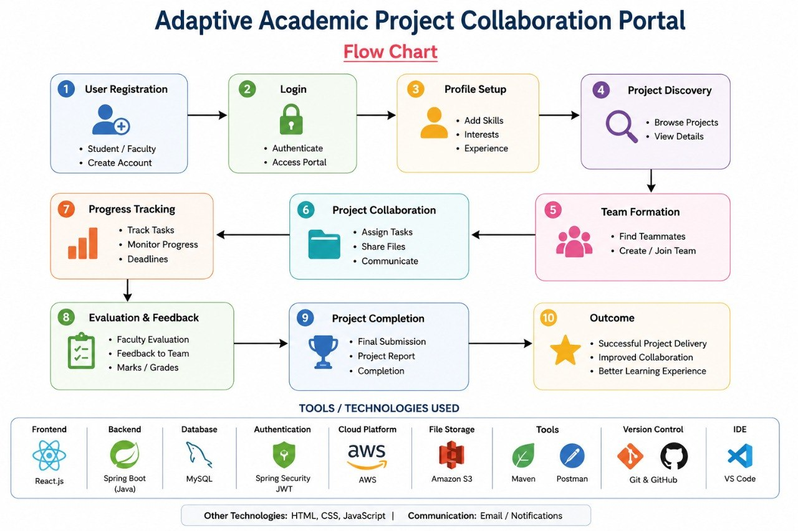
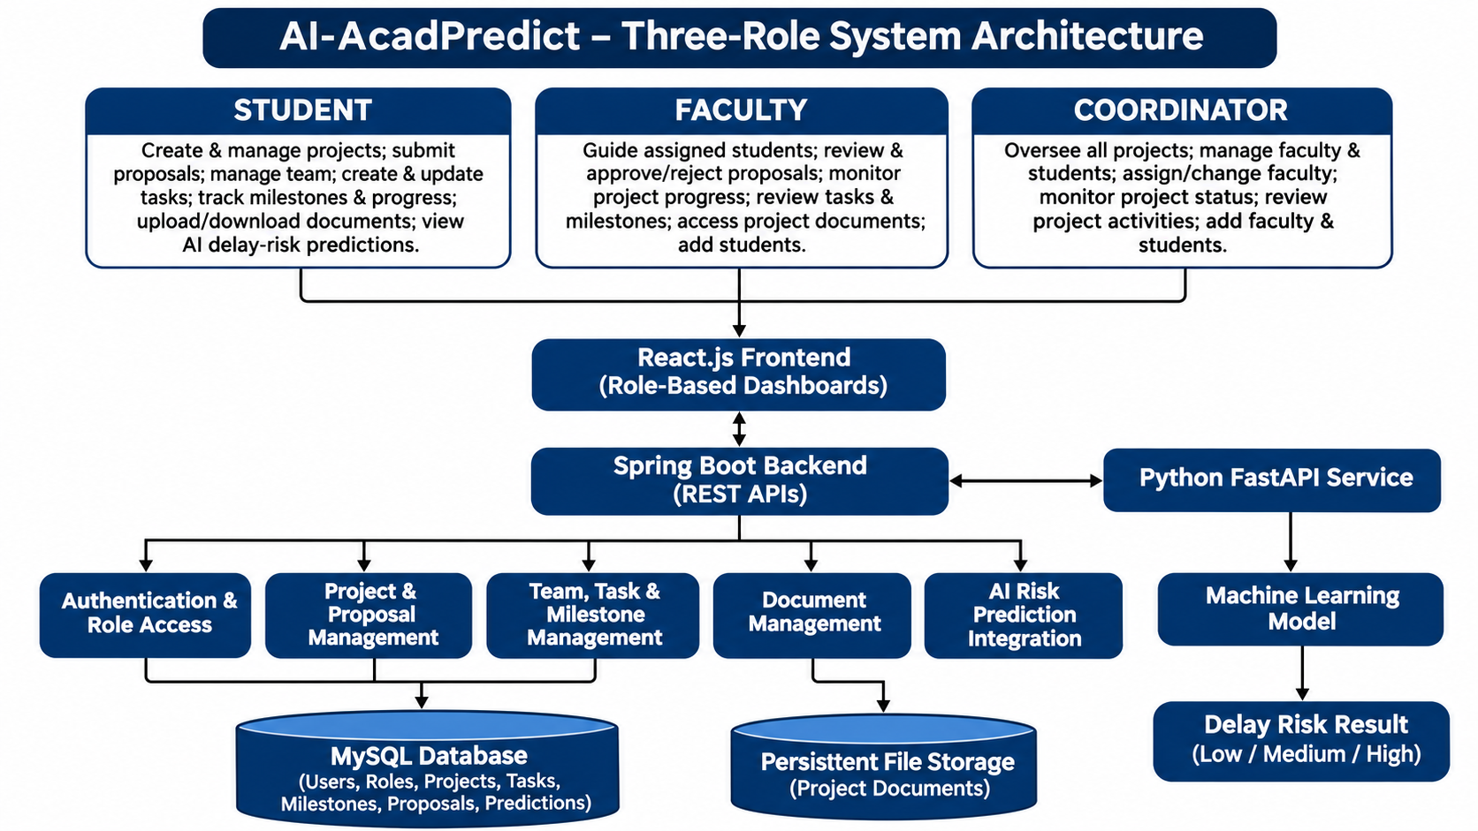

7. RESULTS AND DISCUSSION
The performance of AI-AcadPredict will be evaluated by classifying academic project progress reports into three categories: Low Risk, Medium Risk, and High Risk. The evaluation will focus on the ability of the proposed machine-learning models to identify project delay risks from textual progress reports.
1. Dataset Summary:
The dataset source, total number of records, class distribution, and training, validation, and testing split will be documented after the dataset is finalized.
2. Preprocessing Results:
The collected progress reports will be preprocessed by handling missing values and duplicate records, cleaning the text, and converting the textual information into numerical features using Term Frequency–Inverse Document Frequency (TF-IDF).
3. Model Comparison:
Multinomial Naive Bayes and Logistic Regression classifiers will be trained and compared. Their performance will be evaluated using accuracy, precision, recall, and F1-score.
4. Evaluation Figures:
A confusion matrix and class-wise performance chart will be generated using actual test-set predictions. A Receiver Operating Characteristic (ROC) curve may also be included if the evaluation setup supports it.
5. Discussion and Limitations:
The evaluation will analyse misclassified progress reports, class imbalance, dataset quality, and the limitations of text-based risk prediction. The results will help assess the suitability of the models for identifying academic project delay risks and supporting timely intervention.
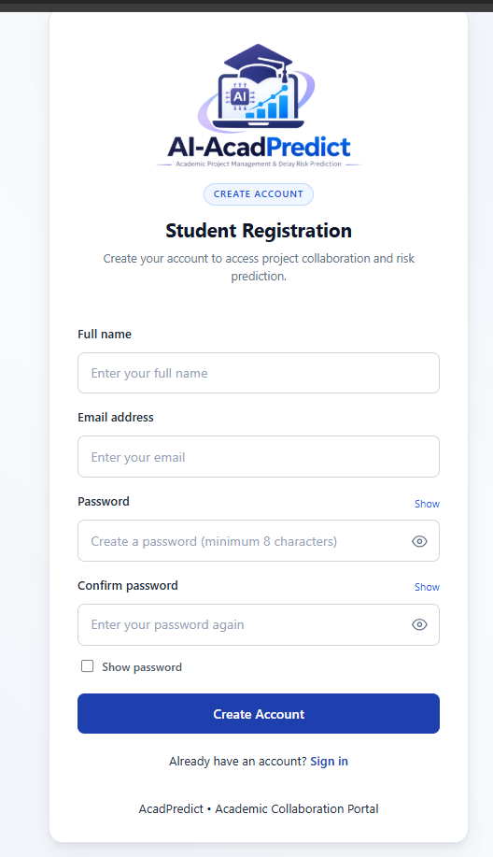

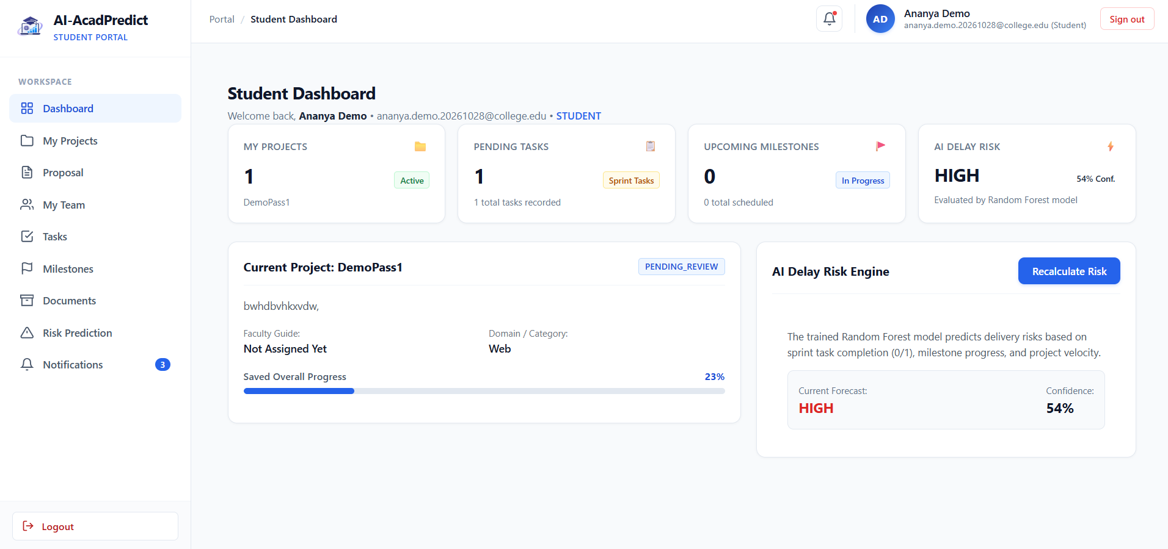

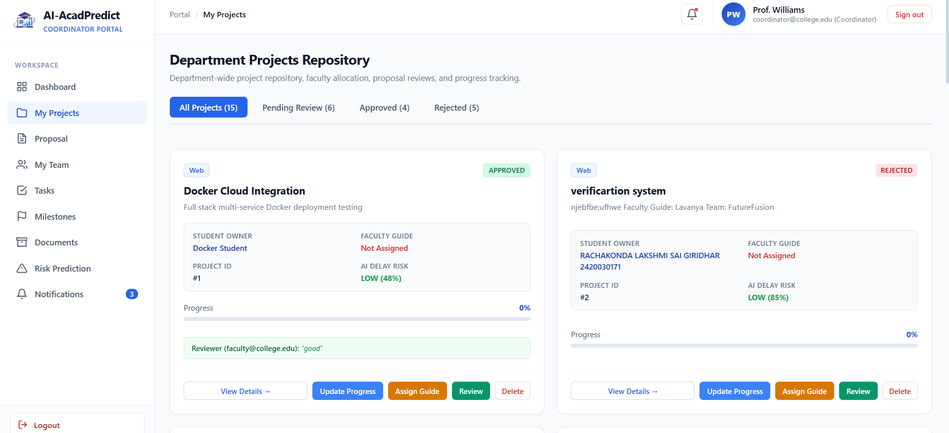

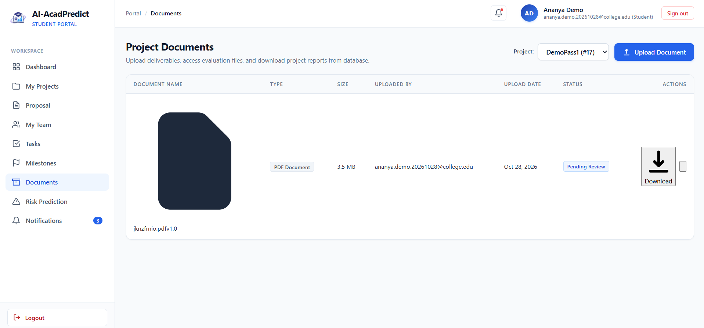

8. CONCLUSION AND FUTURE SCOPE
8.1 Conclusion
AI-AcadPredict aims to analyse academic project progress reports and classify projects into Low Risk, Medium Risk, and High Risk categories using text analytics and machine-learning techniques. The proposed approach involves text preprocessing, TF-IDF feature extraction, and the comparison of Multinomial Naive Bayes and Logistic Regression classifiers.
The performance of these models will be evaluated using accuracy, precision, recall, F1-score, and a confusion matrix. The effectiveness of the proposed system can be determined only after implementation, model training, and testing using a suitable labelled dataset. One of the major challenges is the availability and quality of labelled academic project progress reports, which may influence the reliability and generalization of predictions.Overall, AI-AcadPredict is intended to support early identification of academic project delays and help students, faculty, and project coordinators take timely corrective actions.
8.2 Future Scope
The following improvements may be considered in future versions of AI-AcadPredict:
- Larger and Diverse Datasets: Use larger datasets containing progress reports from different academic domains to improve model generalization.
- Class Imbalance Handling: Apply techniques such as class weighting or resampling to improve the detection of high-risk projects.
- Advanced NLP Models: Explore transformer-based models such as BERT to improve contextual understanding of academic project reports.
- Explainable AI: Introduce explainability techniques to identify important words, phrases, or report features influencing risk predictions.
- Real-Time Application: Develop a web interface or API that allows users to submit progress reports and receive risk predictions.
- Privacy-Aware Processing: Implement appropriate data protection measures to safeguard students' reports and other confidential project information.

9. REFERENCES
1. Dataset documentation or original dataset publication
To be added after selecting the dataset. Include the dataset creator or organization, title, publication year, official URL, and access date. Ensure the dataset contains labelled text suitable for the project’s risk-classification task.

2. Research paper related to text analytics
Sebastiani, F. (2002). “Machine Learning in Automated Text Categorization.” ACM Computing Surveys, 34(1), 1–47. https://doi.org/10.1145/505282.505283.
dblp.org

3.Research paper related to text preprocessing or feature representation
Salton, G., & Buckley, C. (1988). “Term-weighting Approaches in Automatic Text Retrieval.” Information Processing & Management, 24(5), 513–523. https://doi.org/10.1016/0306-4573(88)90021-0.

4. Research paper related to machine-learning algorithms
Pang, B., Lee, L., & Vaithyanathan, S. (2002). “Thumbs Up? Sentiment Classification Using Machine Learning Techniques.” In Proceedings of EMNLP 2002, pp. 79–86. https://doi.org/10.3115/1118693.1118704.
ACL Anthology

5. Scikit-learn documentation
Scikit-learn developers. Scikit-learn: Machine Learning in Python. https://scikit-learn.org/stable/
Relevant documentation:
- TF-IDF vectorization: https://scikit-learn.org/stable/modules/feature_extraction.html#text-feature-extraction
- Multinomial Naive Bayes: https://scikit-learn.org/stable/modules/naive_bayes.html
- Logistic Regression: https://scikit-learn.org/stable/modules/linear_model.html#logistic-regression
- Model evaluation: https://scikit-learn.org/stable/modules/model_evaluation.html

